**Sample Numericals for Autumn End Semester Examination 2024-25**

**Distributed Operating System (CS30009)**

**Q1.** Construct 16 × 16 omega network for communication between 8 computers and 8 memory locations and calculate the following:

1. Total number of stages used in the network.
2. Total number of switches required in the network.
3. Total number of switches required in every stage of the network.

**Q.2.** Suppose that the time to do a null RPC (i.e., 0 data bytes) is 2.0 msec, with an additional 2.5 msec for every 1K of data. How long does it take to read 42K from the file server in a single 42K RPC? How about as 42 1K RPCs?

**Q.3**. Consider the behaviour of two machines in a distributed system. Both have clocks that are supposed to tick 12000 times per millisecond. One of them actually does, but the other ticks only 1000 times per millisecond. If UTC updates come in once a minute, what is the maximum clock skew that will occur?

**Q.4**. A process with transaction timestamp 100 needs a resource held by a process with transaction timestamp 150. Compare the results when:

1. Wait-die deadlock prevention algorithm is used.
2. Wound-wait deadlock prevention algorithm is used.

**Q.5:**

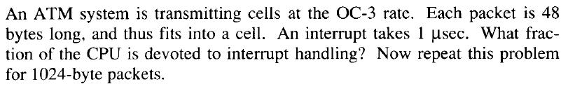

**Q.6:**

